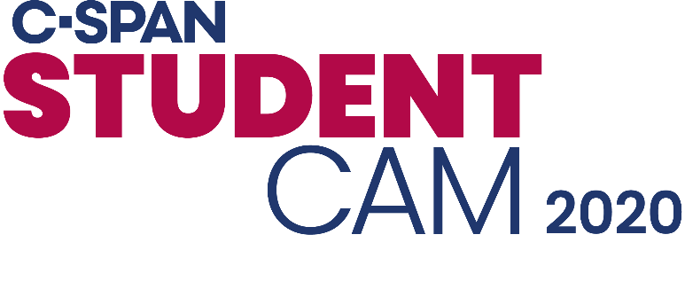 CABLE LOGO

Dear (PRINCIPAL),
Congratulations to you and (SCHOOL) for having (a) winner(s) in C-SPAN's 2020 StudentCam Documentary Competition!
On StudentCam's 16th year, Your students tackled issues of national significance by sharing their opinion on what matters to them in the 2020 election. (STUDENT NAME) and (TEACHER NAME) passionately worked on this documentary where they shared their view on matters that are important to them, our community, and the nation. We are excited to partner with C-SPAN on this project giving students the platform to share their voices on a national stage.
(CABLE) is proud to honor your winning students and hope you join us in celebrating this terrific accomplishment.
We encourage you to watch and share (STUDENT'S) video as well as all the other winning videos anytime at www.studentcam.org. [If you have Grand, First, or Second prize winner: Additionally, (CABLE) if offering (WINNING STUDENT'S) video on Video on Demand through (DATE).] If you have any questions about the project, please email educate@c-span.org.
Thank you and congratulations once again,
(YOUR SIGNATURE)
For more information about C-SPAN Classroom, C-SPAN's free membership service for civics and government educators, visit www.c-span.org/classroom.

